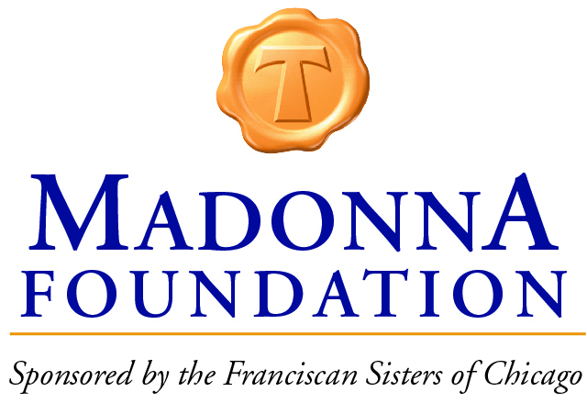

Madonna Scholarship Application Check List

2019-2020 School Year

New Scholar Applicants
A Completed Application Consists Of:
- Application Form:
  - Completed Guardian and Parent Information
  - Financial Information and Documentation from Parent/Guardian
  - Student Information and Questionnaire Form
  - Essay from Student
  - 8th Grade Report Card
  - A letter of Recommendation from current Teacher or Administrator

Returning Scholar Applicants
A Completed Application Consists Of:
- Application Form:
  - Completed Guardian and Parent Information
  - Financial Information and Documentation from Parent/Guardian
  - Scholar Information and Questionnaire Form
  - Essay from Student
  - A letter of Recommendation from current Teacher or Administrator

